Slot Machine Model – Portfolio Project
Excel-based simulation and theoretical validation of a 3-reel slot with RTP, hit rate and volatility analysis
Will Morris
BSc Mathematics, Cardiff University

Introduction
This project demonstrates my ability to design and analyse slot machine mathematics using a combination of probability theory, Excel modelling, and simulation. I built a 3-reel slot machine model with a single payline, incorporating both two-of-a-kind and three-of-a-kind payouts.
The model includes configurable reel strips, a paytable, random spin generation, and win evaluation logic. It calculates key performance indicators such as return to player (RTP), hit rate, and volatility. To validate the design, I compared theoretical probabilities (derived from symbol distributions on the reels) against simulated results generated from thousands of spins in Excel.
This portfolio piece highlights how mathematical design choices — such as reel symbol frequencies and payout multipliers — influence player experience as well as showing my ability to balance both RTP compliance and gameplay feel.

Methodology
The slot machine model was built in Microsoft Excel. It is organised into several linked sheets, each responsible for a different part of the game logic.
1. Configuration
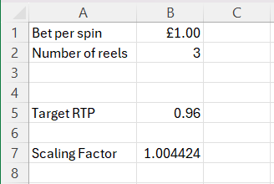
The Config sheet holds global settings:
- Bet size (default £1).
- Target RTP (e.g., 96%).
- Scaling factor used to adjust the paytable so that the theoretical RTP matches the target.

2. Paytable
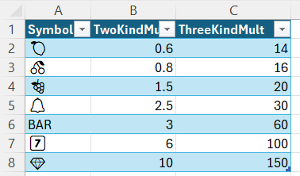
The Paytable sheet specifies the multipliers for two and three-of-a-kind wins. For example, 🍒 pays 0.8× bet for two-of-a-kind and 16× bet for three-of-a-kind, while 💎 pays 10× for two-of-a-kind and 150× for three-of-a-kind. This ensures common symbols give frequent small wins, while rarer symbols create occasional high-value payouts.

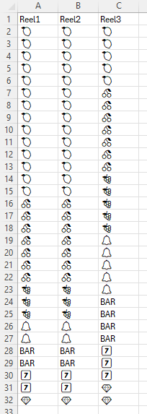
3. Reel Strips
The Reels sheet defines the symbol distribution for each reel. Each reel is 31 stops long and contains a mixture of low symbols (🍒, 🍋, 🍇), mid symbols (🔔, BAR), and premium symbols (7️⃣, 💎). The frequency of each symbol controls the probability of two and three-of-a-kind outcomes.
4. Spin Simulation
The Spins sheet generates thousands of random spins using:
- RANDBETWEEN() to pick a stop index for each reel.
- INDEX() to return the symbol at that stop.
- Logic to check for winning combinations: priority is given to three-of-a-kind, otherwise two-of-a-kind on reels 1–2, otherwise no win.
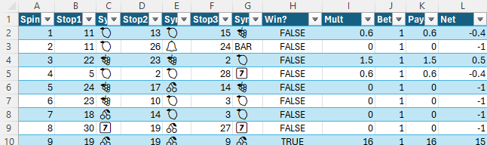
- Payout calculation as multiplier × bet, and Net as payout − bet.

5. Results
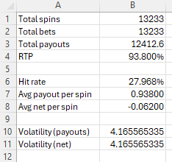
The Results section summarises performance across all spins:
- RTP = total payouts ÷ total bets.
- Hit rate = proportion of spins that return a win.
- Volatility = standard deviation of net returns, measuring risk.

6. Theoretical Analysis
To validate results, a theory block computes exact probabilities for each symbol:
- P3 (3-oak probability): (c₁/L₁)(c₂/L₂)(c₃/L₃).
- P2 (2-oak probability): (c₁/L₁)(c₂/L₂)(1 − c₃/L₃).
- Contribution: probability × multiplier for each case.

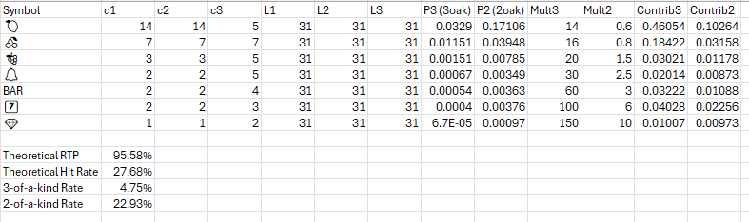
Summing across symbols yields theoretical RTP and hit rate, which are compared against simulated results to confirm accuracy.
This structure allows for rapid experimentation. Adjusting reel counts or paytable multipliers immediately updates both the simulation and theoretical calculations, making it possible to test multiple game profiles (low, medium, or high volatility) and confirm balance against a chosen RTP target.

Results & Validation
To confirm that the slot model was correctly implemented, I compared the theoretical probabilities (derived from reel symbol distributions) against the simulated outcomes (from thousands of random spins in Excel).
The table below shows the key performance indicators for one representative setup (31 stops per reel, RTP target 96%):
Metric | Theoretical | Simulated (>13,000 spins)
RTP | 95.58% | 93.8%
Hit Rate | 27.68% | 27.97%
Volatility | - | 4.166

- RTP: The simulated RTP converged very closely to the theoretical value, with only a 1.78% deviation after >13,000 spins.
- Hit Rate: The simulated hit rate matched the theoretical expectation within 0.29%, showing that the reel logic and payout evaluation were consistent.
- Volatility: Volatility was measured only in simulation, using the standard deviation of net returns. This metric reflects the spread of outcomes, with higher volatility games producing more extreme wins and losses.
The close match between theory and simulation demonstrates that the underlying formulas for symbol probabilities and win conditions are correct. Running larger simulations (e.g., 100,000+ spins) further confirmed convergence of RTP and hit rate to theoretical targets.

Variation & Design Insights
Although this project focused on a single reel setup, I also explored how changes to the reel strips and paytable multipliers affect the overall performance metrics. Even small adjustments can significantly alter hit rate, RTP contribution per symbol, and volatility.
- Reel distribution:
Increasing the frequency of common symbols (🍒, 🍋) on reels 1 and 2 raises the hit rate, because two-of-a-kind outcomes become more likely. Conversely, reducing their frequency lowers the hit rate and shifts the game toward higher volatility.
- Reel 3 composition:
Changing the proportion of symbols on reel 3 adjusts the split between two-of-a-kind and three-of-a-kind wins. A lower presence of common symbols on reel 3 increases the share of small two-of-a-kind wins, while higher presence boosts the probability of three-of-a-kind outcomes and therefore bigger but rarer payouts.
- Paytable multipliers:
Scaling multipliers upward for rare symbols like 💎 or 7️⃣ increases volatility and produces large spikes in RTP contribution from a small number of wins. Reducing multipliers on frequent symbols flattens the payout curve, creating a lower-volatility experience.
In practice, game designers use these levers to produce “profiles” — such as a low-volatility game with frequent small wins, or a high-volatility game with rare but large jackpots. My model demonstrated these relationships clearly, even with a single reel setup, by showing how theoretical hit rate and RTP contributions respond directly to reel and paytable adjustments.

Extensions
This project can be extended in several directions to more closely resemble commercial slot mechanics:
- Scatters: Symbols that pay anywhere on the reels, independent of paylines. For example, ⭐ appearing three times across any reels could award a fixed prize.
- Wilds: A special symbol that substitutes for others, increasing the chance of two- and three-of-a-kind wins.
- Multiple paylines: Expanding from a single payline to a 3×3 grid with 5+ paylines (horizontal and diagonal) significantly increases hit frequency and complexity.
- High-volume simulation: Automating 100,000+ spins in VBA would allow RTP convergence to be visualised in real time, demonstrating statistical accuracy of the model.
Even without implementing all of these, describing how they could be added shows an understanding of game design complexity and scalability.

Conclusion
This project demonstrates my ability to design and analyse slot machine mathematics in Excel, applying probability theory, simulation, and clear presentation of results.
- I created a 3-reel slot with configurable reel strips and paytable.
- I calculated theoretical RTP and hit rate from symbol distributions, and validated them against simulated outcomes.
- I showed how changes to reel composition and multipliers influence hit frequency, RTP contributions, and volatility.
- I documented the process in a structured, professional format, suitable for both technical review and non-technical stakeholders.
By combining theoretical calculations with practical simulation, this portfolio piece highlights strong skills in probability, applied mathematics, and Excel modelling, all directly relevant to roles in game mathematics, data analysis, and applied quantitative problem solving.

